**INTRODUCTION**

**What is Python?**

Python is a popular programming language. It was created in 1991 by Guido van Rossum.

**It is used for:**

* Web development
* Software development
* Mathematics
* System scripting
* Computations and Analysis

**What can Python do?**

* Python can be used on a server to create web applications.
* Python can be used alongside software to create workflows.
* Python can connect to database systems. It can also read and modify files.
* Python can be used to handle big data and perform complex mathematics.
* Python can be used for rapid prototyping, or for production-ready software development.

**Why Python?**

* It is Dynamically typed means no need to declare the variable types.
* Python works on different platforms (Windows, Mac, Linux, Raspberry Pi,etc).
* Python has a simple syntax similar to the English language.
* Python has syntax that allows developers to write programs with fewer lines than some other programming languages.
* Python runs on an interpreter system, meaning that code can be executed as soon as it is written. This means that prototyping can be very quick.
* Python can be treated in a procedural way, an object-orientated way or a functional way.

**Python Syntax compared to other programming languages**

* Python was designed to for readability, and has some similarities to the English language with influence from mathematics.
* Python uses new lines to complete a command, as opposed to other programming languages which often use semicolons or parentheses.
* Python relies on indentation, using whitespace, to define scope; such as the scope of loops, functions and classes. Other programming languages often use curly-brackets for this purpose.

**ABOUT PROJECT**

Image recognition, in the context of machine vision, is the ability of software to identify objects, places, people, writing and actions in images. Computers can use machine vision technologies in combination with a camera and artificial intelligence software to achieve image recognition.Image recognition is used to perform a large number of machine-based visual tasks, such as labeling the content of images with meta-tags, performing image content search and guiding autonomous robots, self-driving cars and accident avoidance systems.There are many kind of Image recognition but our group has only focused on facial recognition using the library function Face_Recognition(Built in dlib). It Recognize and manipulate faces from Python or from the command line with the world's simplest face recognition library.

**Features Of our Project:**

* Find faces in pictures
* Recognize faces in a live video Using Web Cam

**SOURCE CODE**

import cv2

import face_recognition

import math

import numpy as np

video=cv2.VideoCapture(0

shabnam_image = face_recognition.load_image_file("F:\\python project\\Known faces\\Shabnam.jpg")

shabnam_face_encoding = face_recognition.face_encodings(shabnam_image)[0]

hasibul_image = face_recognition.load_image_file("F:\python project\Known faces\\Hasibul.jpg")

hasibul_face_encoding = face_recognition.face_encodings(hasibul_image)[0]

rehan_image = face_recognition.load_image_file("F:\\python project\\Known faces\\Rehan.jpg")

rehan_face_encoding = face_recognition.face_encodings(rehan_image)[0]

maruf_image = face_recognition.load_image_file("F:\\python project\\Known faces\\Maruf.jpg")

maruf_face_encoding = face_recognition.face_encodings(maruf_image)[0]

Arisha_image = face_recognition.load_image_file("F:\\python project\\Known faces\\arisha.jpg")

Arisha_face_encoding = face_recognition.face_encodings(Arisha_image)[0]

known_face_encodings = [

maruf_face_encoding,

rehan_face_encoding,

hasibul_face_encoding,

shabnam_face_encoding,

Arisha_face_encoding

]

known_face_names = [

"maruf",

"rehan",

"Hasibul",

"Shabnam",

"Arisha"

]

while True:

face_names=[]

lval=[]

rit,frame=video.read()

small_frame = cv2.resize(frame, (0, 0), fx=1, fy=1)

face_locations=face_recognition.face_locations(small_frame)

face_encodings = face_recognition.face_encodings(small_frame, face_locations)

for face_encoding in face_encodings:

matches = face_recognition.compare_faces(known_face_encodings, face_encoding)

if True in matches:

first_match_index = matches.index(True)

name = known_face_names[first_match_index]

face_distances = face_recognition.face_distance(known_face_encodings, face_encoding)

face_match_threshold=0.6

for face_distance in face_distances:

if face_distance < face_match_threshold:

range = face_match_threshold

linear_val = 1.0 - (face_distance / (range * 2.0))

l=round((linear_val + ((1.0 - linear_val) * math.pow((linear_val - 0.5) * 2, 0.2)))*100)

l=str(l)

else:

name="Unknown"

l="Null"

lval.append(l)

face_names.append(name)

for (top, right, bottom, left), name,l in zip(face_locations, face_names,lval):

cv2.rectangle(frame, (left, top), (right, bottom), (0, 0, 255), 2)

font = cv2.FONT_HERSHEY_DUPLEX

cv2.putText(frame, name, (left + 6, bottom - 6), font, 0.50, (255, 255, 255), 1)

cv2.putText(frame, l+"%", (left + 80, bottom - 6), font, 0.50, (255, 255, 255), 1)

cv2.imshow("capture",frame)

key=cv2.waitKey(1)

if key == ord("q"):

break

video.release()

cv2.destroyAllWindows()

**OUTPUT**

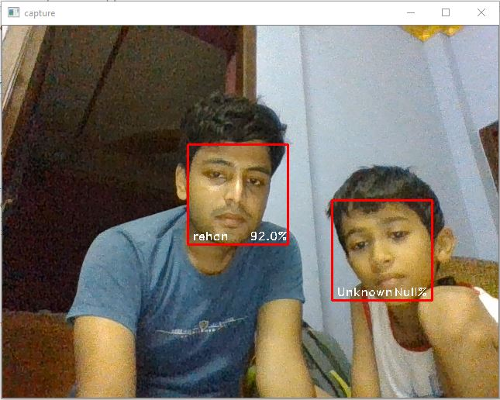

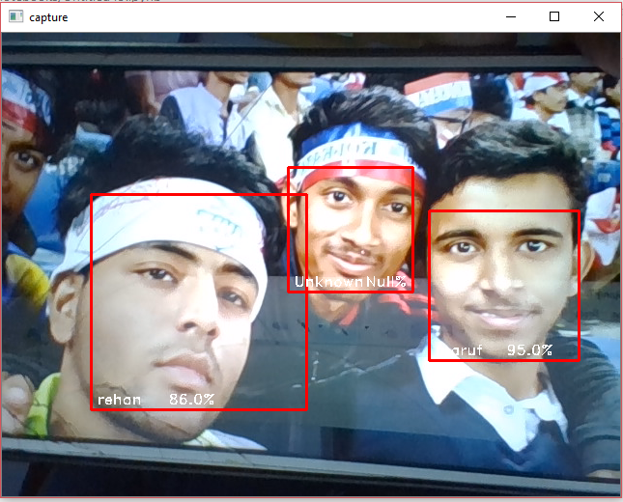



**SUMMER INDUSTRIAL TRAINING 2019**

**Subject:- Machine Learning Using Python**

**Project Name:- Image Recognition**

**Submitted To:-**

**Subhadeep Chakraborty**

**Submitted By:-**

**GROUP IV**

**Sk Rehan Ahamed**

**Shabnam Parween**

**Maruf Hassan**

**Hasibul Mandal**

**Arisha Aftab**

**Samadur Khan**

**Sign:-……………………..**